Homework2

CSC 675/CSC 775

*© 2021 SFSU All Rights Reserved*

Homework 2 will focus on problems from chapters 3, 4 and 5 of the book.

**Q1 (24 points)** Consider the following ER diagram for an apartment rental application.

Write the SQL-DDL statements, to create tables for the following ER diagram and capture as many of the constraints as possible. Specify your decisions with the foreign key constraint.

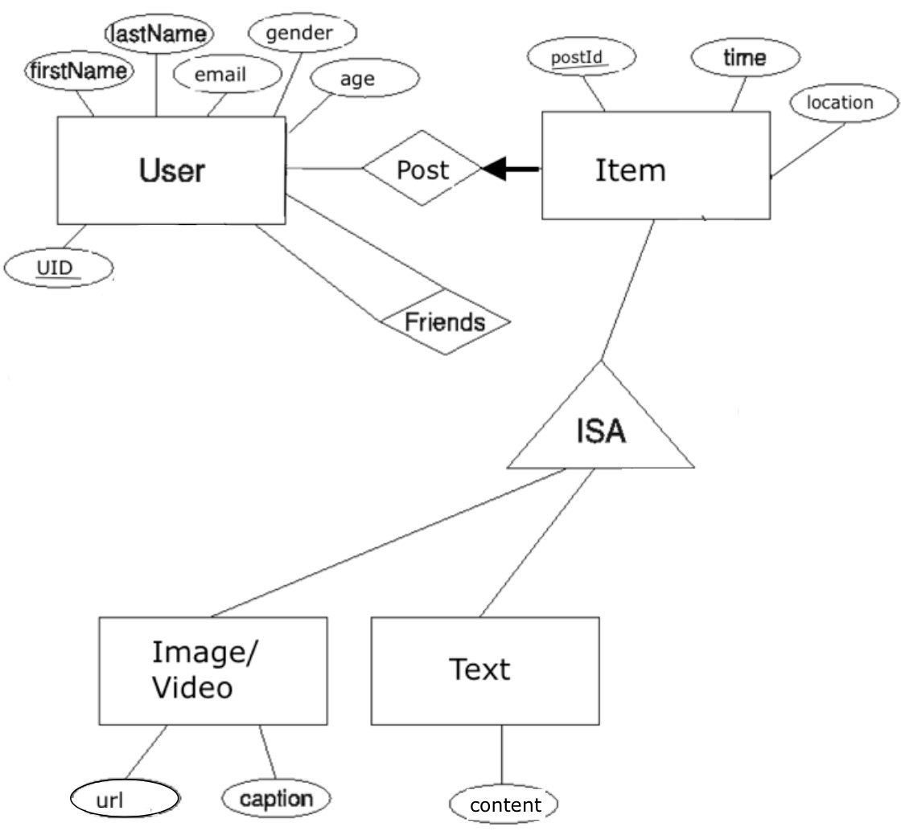

CREATE TABLE User(

UID int primary key,

firstName varchar(50),

lastName varchar(50),

email varchar(50),

gender varchar(10),

age int

);

CREATE TABLE ItemPost (

postId int primary key,

time time,

location varchar(50),

UID int,

Foreign key (UID) references User (UID)

);

CREATE TABLE friends (

UID int,

Fid int,

Primary key (UID, fID)

Foreign key (UID) references User (UID)

Foreign key (fID) references User (UID)

);

CREATE TABLE Texts(

postId int primary key,

content varchar(500),

foreign key (postId) references ItemPost(postId)

);

CREATE TABLE ImageVideo(

postId int primary key,

url varchar(50),

caption varchar(100),

foreign key(postId) references ItemPost(postId)

);

**Q2. (10 points, 2 points each)** Assume we have the following instance of table sailors:

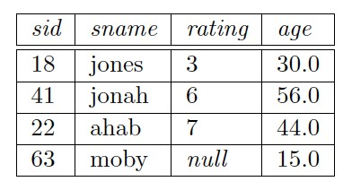

1. What is the result of this query:

SELECT AVG (S.rating)

FROM Sailors S

3+6+7 / 4 = 4

1. What is the result of this query:

SELECT SUM (S.rating)

FROM Sailors S

3+6+7 = 16

1. What is the result of this query:

SELECT COUNT (S.rating)

FROM Sailors S

1. Show the left outer join of S with itself, with the join condition being sid=sid.

1. Show the right outer join of S with itself, with the join condition being sid=sid.

**Q3. (6 points)**

a. Which one of the following queries finds sailors who have reserved at least a boat but not a red boat?

*Query1:*

*SELECT R.sid*

*FROM Boats B, Reserves R*

*WHERE B.bid=R.bid AND B.color<>’red’*

*Query2:*

*SELECT R.sid*

*FROM Reserves R*

*EXCEPT*

*SELECT R.sid*

*FROM Boats B, Reserves R*

*WHERE B.bid=R.bid AND B.color=’red’*

b. What are the results of query1 and query2 in part A, considering the following instances of Boats and Reserves tables?

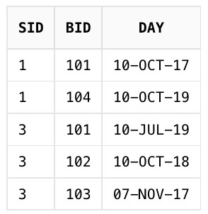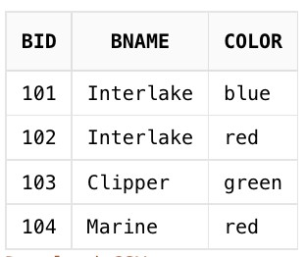

**Q4. (24 points, 6 points each)**  Consider boat reservation database. Answer these questions using SQL.

1. Find the names of sailors with a higher rating than all sailors who are younger than 20 .

SELECT sname FROM s s1 WHERE NOT EXISTS (SELECT * FROM s S2 WHERE S2.age < 20 AND s.rating <= S2.rating)

1. Find name of sailors who have not reserved a boat whose name includes the string “Marine”.

SELECT sname FROM s s1 WHERE sid NOT IN (SELECT sid FROM r, s WHERE r.sid = s.sid AND sname LIKE ‘%Marine%’)

1. Find the names of sailors who have reserved at least two boats.

SELECT sname FROM s, r r1, r r2 WHERE s.sid = r1.sid AND s.sid = r2.sid AND r1.bid<>r2.bid

1. For each boat reserved by at least 2 sailors older than 20, find the boat id and the average age of such sailors.

SELECT bid, AVG(age) FROM b, r, s WHERE s.age > 20 AND b.bid = r.bid AND s.sid = r.sid GROUP BY bid HAVING 2 <= COUNT(DISTINCT s.sid)

**Q5. (24 points, 6 points each)** Consider the following schema:

Suppliers(sid: integer , sname: string , address: string )

Parts(pid: integer , pname: string , color: string )

Catalog(sid: integer , pid: integer , cost: real )

The Catalog relation lists the prices charged for parts by Suppliers. Write the following queries in SQL:

1. Find the name s of suppliers who supply every red part.
2. Find the sid s of suppliers who supply only red parts.

1. Find the name s of parts supplied by “Acme Suppliers” and no one else.

1. Find name of suppliers who charge for some parts less than the average price of that part.

**Q6. (12 points, 6 points each)** Consider the following relational schema:

STUDENT(SID, SNAME, DEPT)

ENROLL(CID, SID, GRADE, SEMESTER)

COURSE(CID, DEPT)

Write the following SQL queries in Relational Algebra:

A.

SELECT S.SNAME

FROM STUDENT S, ENROLL E

WHERE S.SID=E.SID AND E.CID=’CSE565’

B.

SELECT *

FROM STUDENT S

WHERE NOT EXISTS (SELECT *

FROM ENROLL E

WHERE E.SID = S.SID AND E.GRADE = 4.0)